BIT4138 : ADVANCED CRYPTOGRAPHY
Student details
Student Name :Hibaq Abdi Muktar
Admission Number: BSCCS/2024/34174
Course:Computer Science
Unit Code: BIT3208
Unit Name: Advanced Cryptography
Lecturer Name: Mr. Michael Nyoro
Semester/Academic Year: 2025/2026
Project details
Project Title:
Secure File Encryption System with SQLite
Selected Technologies:
Python + SQLite
GitHub link
https://github.com/Hibaq434/Advanced-cryptotography-project.git

Contents
Week 1: Cryptography Environment Setup 3
Fig 1: Python Version Verification 3
Fig 2: Installation of Cryptography Libraries 3
Fig 3: OpenSSL Installation Test 4
Fig 1: Caesar Cipher Implementation 5
Caesar Cipher implementation encrypting and decrypting the phrase “HELLO CYBERSECURITY ENTHUSIAST” with a shift of 3. 5
5
Fig 2: Vigenère Cipher Encryption Process 5
Week 3: Stream Ciphers and Randomness Testing 7
7
8
Week 4: Block Cipher Design and AES 9
Week 5: Public Key Cryptography (RSA) 11
11
11

Week 1: Cryptography Environment Setup
Installation and Configuration of Cryptography Development Environment
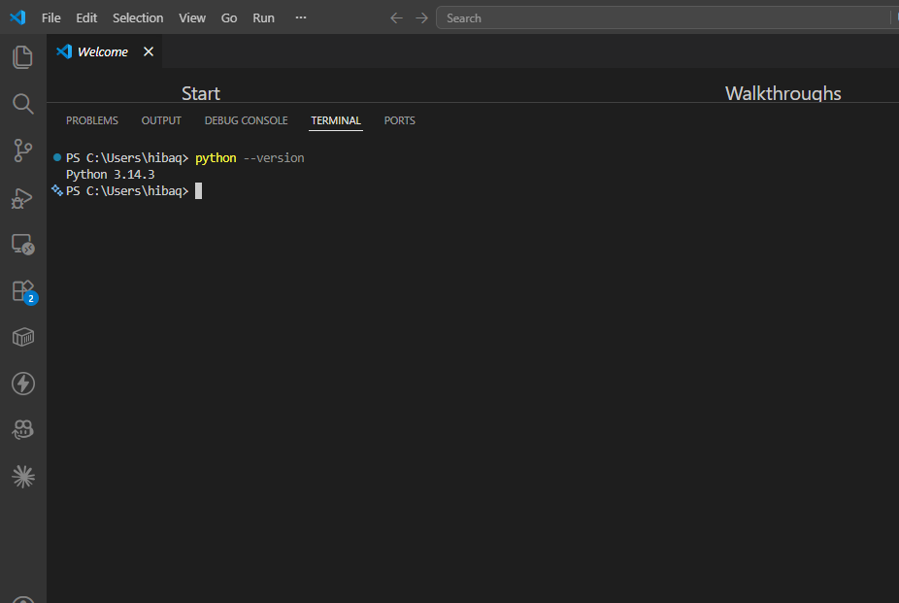

Fig 1: Python Version Verification
confirms that Python is successfully installed and properly configured in the system environment, providing the required runtime for cryptographic programming and execution of security scripts
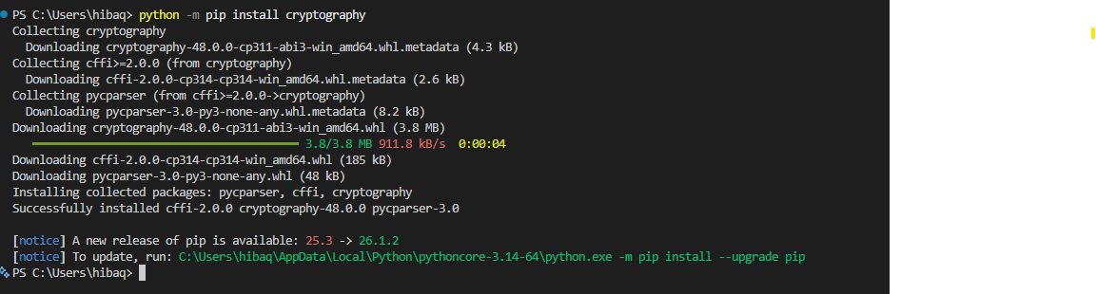

Fig 2: Installation of Cryptography Libraries

Fig 2 confirms successful installation of the Python cryptography library and its dependencies, which are essential for implementing encryption, decryption, and secure data handling operations.

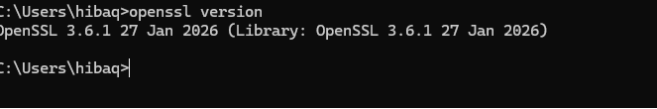

Fig 3: OpenSSL Installation Test
Fig 3 confirms successful installation and configuration of OpenSSL, which is used for generating cryptographic keys, certificates, and supporting secure communication protocols.

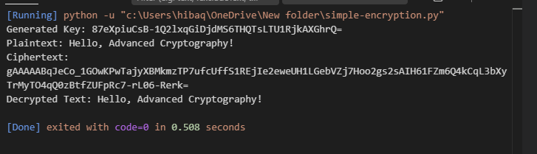
Fig 4: Local encryption script execution demonstrating successful encryption and decryption using Python cryptography library.
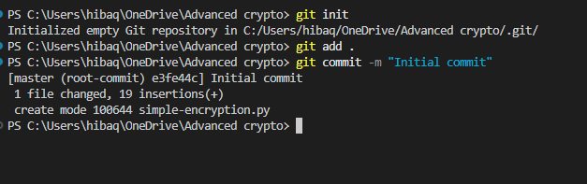
Fig 5: GitHub repository initialized with first commit for Advanced Cryptography project.
Student Reflection
Configured Python, VS Code, and OpenSSL successfully. Verified cryptography libraries and tested a simple encryption script. GitHub repository initialized for version control, ensuring secure coding workflow

Week 2: Classical Cryptography and Cipher Design
Implementation of Classical Encryption Algorithms
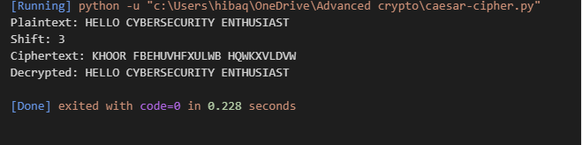

Fig 1: Caesar Cipher Implementation
Caesar Cipher implementation encrypting and decrypting the phrase “HELLO CYBERSECURITY ENTHUSIAST” with a shift of 3.

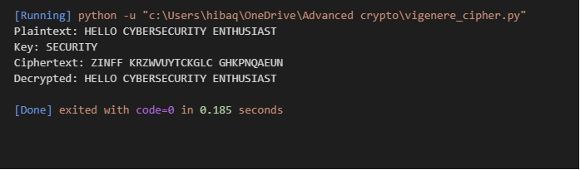

Fig 2: Vigenère Cipher Encryption Process
Fig 2: Vigenère Cipher encryption process using keyword “SECURITY” to encrypt and decrypt the phrase “HELLO CYBERSECURITY ENTHUSIAST.”
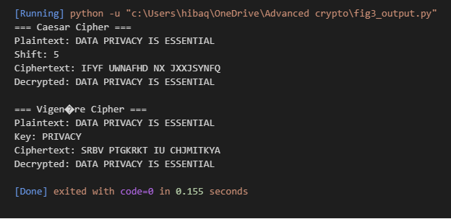
Fig 3: Encryption and decryption output demonstrating Caesar Cipher (shift = 5) and Vigenère Cipher (keyword = PRIVACY) on the phrase “DATA PRIVACY IS ESSENTIAL.”
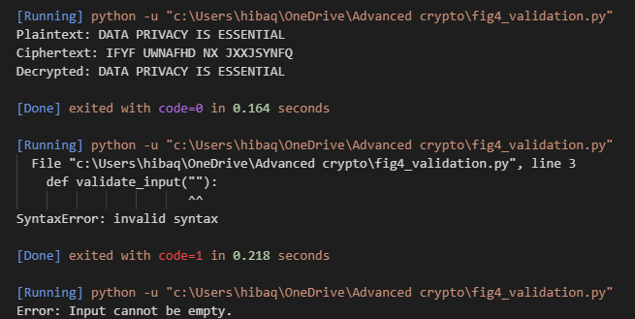
Fig 4: User input validation interface rejecting invalid input and displaying error messages.
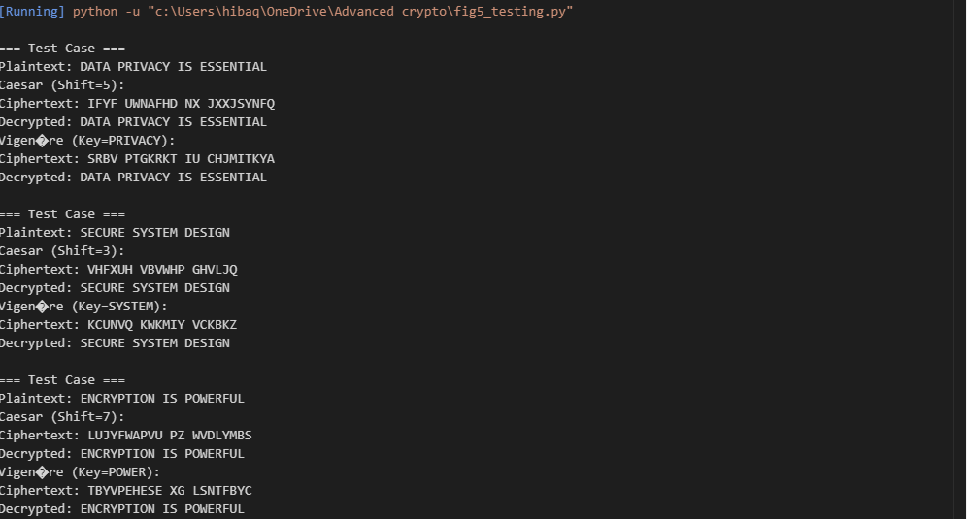
Fig 5: Cipher testing results demonstrating successful encryption and decryption across multiple test cases using Caesar Cipher (different shifts) and Vigenère Cipher (different keys).
Student Reflection
I implemented Caesar and Vigenère ciphers to understand classical encryption. Testing showed how shifts and keywords influence security. Input validation improved reliability, and multiple test cases highlighted weaknesses compared to modern algorithms. This week strengthened my grasp of encryption workflows and the importance of secure key handling

Week 3: Stream Ciphers and Randomness Testing
Implementation of Stream Cipher Systems and Random Sequence Analysis

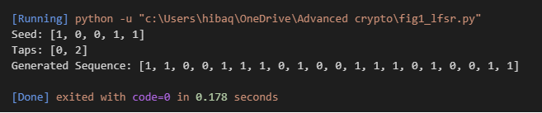
Fig 1: LFSR generator implementation producing a pseudorandom sequence using seed [1,0,0,1,1] and taps [0,2].

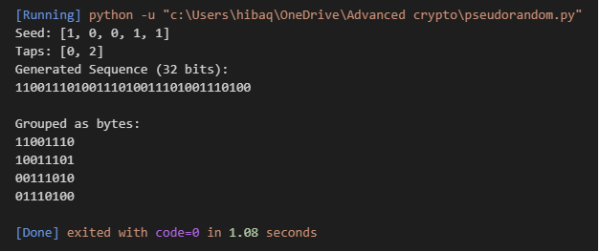
Fig 2: Pseudorandom sequence output generated by LFSR, displayed as a 32-bit stream and grouped into 8-bit chunks.
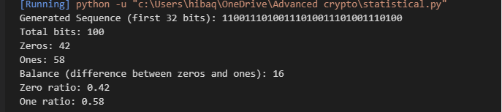
Fig 3: Randomness testing results showing distribution of zeros and ones in LFSR-generated sequence, demonstrating near balance and pseudorandom behavior.
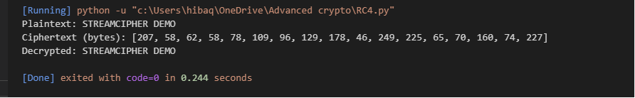
Fig 4: RC4 stream cipher simulation demonstrating successful encryption and decryption using generated keystream.
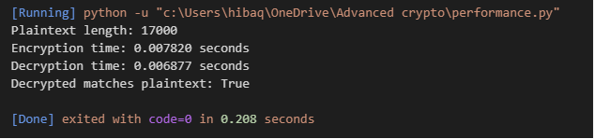
Fig 5: Encryption performance results demonstrating RC4 stream cipher efficiency with measured encryption and decryption times.
Student Reflection
The RC4 implementation demonstrated real-time stream encryption where data is encrypted bit-by-bit. Randomness was tested by analyzing distributions of zeros and ones in pseudorandom sequences. These tests highlighted the importance of pseudorandom generation in ensuring secure keystreams and reinforced how stream ciphers rely on randomness for effective encryption.

Week 4: Block Cipher Design and AES
Advanced Encryption Standard (AES) and Block Cipher Operations
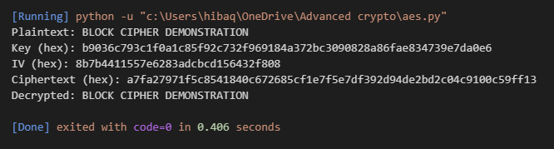
Fig 1: AES encryption script demonstrating secure block cipher encryption and decryption using a 256-bit key and CBC mode.
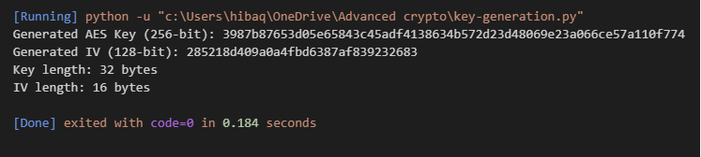
Fig 2: AES key generation process producing a random 256-bit key and 128-bit IV for secure block cipher operations.
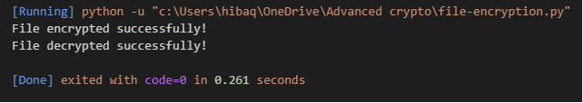
Fig 3: AES file encryption demonstration showing secure encryption of a text file and successful decryption back to original content.
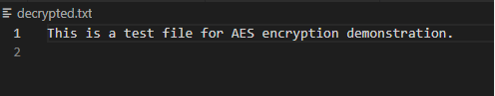
Fig 4: AES decryption results demonstrating successful recovery of original file content from ciphertext.
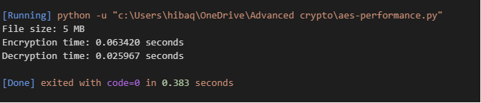
Fig 5: AES performance testing results showing measured encryption and decryption times for a 5 MB file using AES-256 in CBC mode.
Student Reflection
I implemented AES to encrypt and decrypt text files using a 256-bit key and CBC mode. Secure key generation ensured strong protection. Decryption restored original content, confirming workflow correctness. A file-not-found error was encountered and resolved by creating the input file, reinforcing practical debugging skills.

Week 5: Public Key Cryptography (RSA)
Implementation of RSA Encryption and Key Management

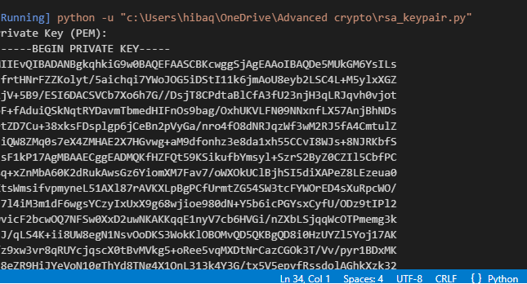

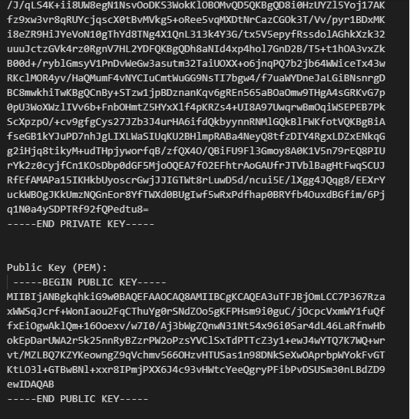
- Fig 1: RSA key pair generation producing a secure 2048-bit private key and corresponding public key for asymmetric encryption.

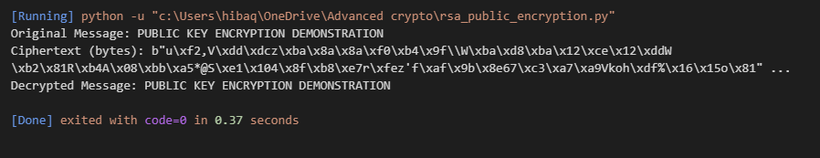
Fig 2: RSA public key encryption process demonstrating secure encryption with the public key and successful decryption with the private key.
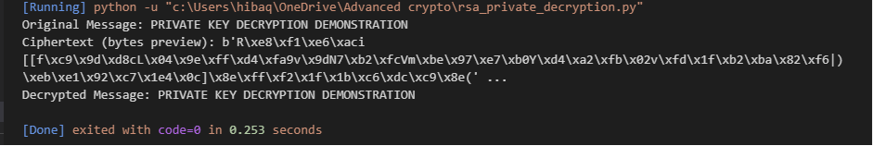
Fig 3: RSA private key decryption results demonstrating successful recovery of plaintext from ciphertext using the private key.
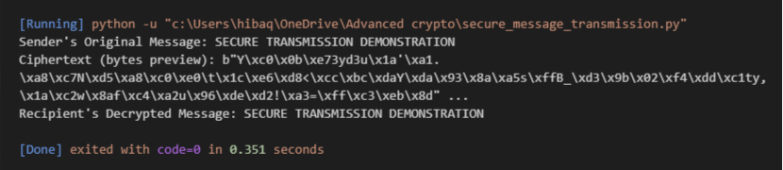
Fig 4: RSA secure message transmission demonstrating encryption with the public key and successful decryption with the private key.
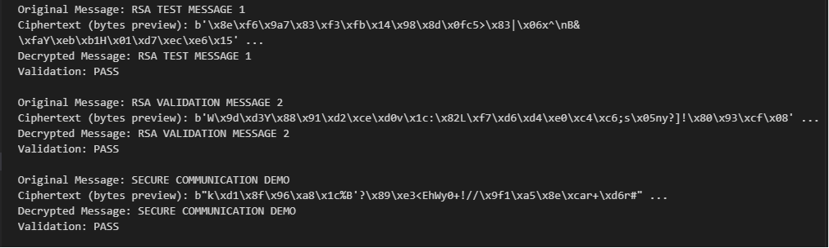
Fig 5: RSA testing and validation demonstrating successful encryption and decryption across multiple test cases, confirming secure key handling and correctness of the RSA workflow.
Student Reflection
RSA encryption highlighted the difference from symmetric methods by using separate public and private keys. The public key encrypted messages while the private key ensured secure decryption. Testing multiple cases validated correctness, demonstrating RSA’s security advantage in protecting communication and confirming the workflow through successful validation results.

